CODE OF CONDUCT FOR PARENTS/GUARDIANS & VISITORS

Introduction
In Gaelscoil Bhaile Munna, we are very fortunate to have a supportive and friendly parent body. We recognise that educating children is a process that involves partnership between parents, teachers and the wider school community. We understand and highly value the importance of a good working relationship as we all work together to set good example for the children entrusted into our care.

Rationale
In order to maintain an orderly, respectful and secure educational environment for pupils and staff of Gaelscoil Bhaile Munna, it is essential that all parents/guardians and visitors to our school be aware of their responsibilities and adhere to the expected code of conduct.

Relationship to School Ethos
The school promotes positive home – school contacts and endeavours to enhance the self-esteem of everyone within the school community. The policy contributes towards those ideals.

Aims/Objectives
The purpose of this guidance is to provide a mutual understanding to all parents/guardians and visitors to our school about the conduct expectations while on school property, attending school events and when interacting with school staff.

Parents/guardians in our school are expected to:
- ensure their child attends school, in full school uniform, unless their child is unwell;
- ensure their child arrives punctually for the start of the school day (8.30a.m.) and is collected punctually at the end of the school day (1.10pm for infants, 2.10pm for rest of the school);
- ensure that any lunch that is sent to school is healthy, in line with the school’s Healthy Eating policy;
- nurture in their children a positive attitude towards school;
- send a written note to the class teacher explaining their child's absence from school;
- ensure the school has up-to-date contact details for family/friends and be contactable in the event of an emergency.
- to make an appointment to meet with the class teacher when they are concerned about any issue relating to their child and to state the purpose of the appointment;
- communicate with staff when necessary, always with courtesy and respect, and to model good behaviour in your relationship with pupils, staff and other parents;
- encourage children to have a sense of respect for themselves, for others, for their own property, school property and that of others;
- label their child’s clothing and other personal belongings;
- be interested in, support, assist and encourage their child's school work and homework;
- attend parent-teacher meetings pertaining to their child;
- be familiar with the code of behaviour and other school policies and to support the implementation of these policies;

- ensure that their child does not bring into school anything which might cause harm to themselves or others;
- be respectful and use appropriate language while on school premises;
- show consideration and an awareness of the safety of all children attending this school, particularly at drop off and collection times;
- co-operate with teachers in instances where their child's behaviour is causing difficulties for others;
- strictly supervise pre-school children, when on school property;
- keep staff informed of any changes which may affect their child in school;
- follow the school's Complaints Procedure if they have a complaint;
- abide by Data Protection legislation in relation to posting video or photos of any member of our school community.

Guidelines for conduct on school property and at school events/activities
- Our school is a place of work and learning. All persons on school property or attending a school event/activity should conduct themselves in a respectful and orderly manner. Anyone who is not a regular staff member or pupil of the school will be considered a visitor.
- All visitors to our school should report to the school office upon arrival. They will be asked to sign the visitor’s book and sign out before leaving.
- All visitors should enter the school through the front doors only. Access by any other door is prohibited to ensure the safety of all our pupils.
- Visitors attending school functions that are open to the public, such as parent-teacher meetings, Christmas Fair, performances, etc. need not register.
- Please bear in mind that teachers are responsible for their pupils during class time and cannot leave a class unattended for meeting during the day. If a parent/guardian needs to meet with a teacher, they should contact the school office to arrange this, clearly stating the purpose of the meeting.
- Staff will only speak about a child to his/her parent/ guardian to respect the child’s right to privacy.
- Stakeholders should not isolate or attempt to influence others against particular individuals or groups in the school.
- Any unauthorised persons on school property will be reported to the principal and will be asked to leave. The Gardaí may be called if a situation warrants this.
- The use of bad language is strictly prohibited.
- Smoking of any substances e.g. cigarettes, e-cigarettes, etc. is prohibited at all times.
- The taking of photographs, audio recordings and/or film recordings without permission is strictly prohibited.
- No visiting adult has permission to approach or reprimand any pupil who is not their own child on school property or during school events/activities.
- All visitors are expected to abide by the guidelines for public conduct as outlined in these procedures.

Digital Harassment
Every staff member is issued with a school email address. The following ground rules apply.
- Emails will be answered within 2 school days.
- Staff are not required to check their emails after 3pm on schooldays.
- Communication via email should always be courteous and respectful.
- The excessive sending of emails to a staff member falls under this policy.

Persons in violation of the Code of Conduct
The Board of Management of Gaelscoil Bhaile Munna is responsible for the Health & Safety of all staff and pupils during school hours and at school-related events/activities. We expect that all adults behave in a manner that is appropriate to a school environment. In the event of any altercation involving an adult on school property or at school events/activities, those involved will be asked to leave the premises or event/activity. If they refuse to leave, the Gardaí will be contacted immediately. The Board considers ANY such altercations as a very serious breach of this Code of Conduct and may take further action.

Ratification & Review
This code will be reviewed as necessary. It was presented to and ratified by the Board of Management on 02/03/2026.
Sínithe:
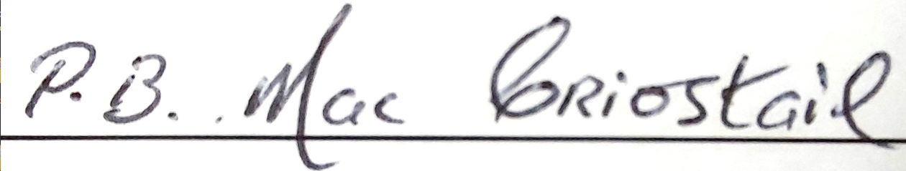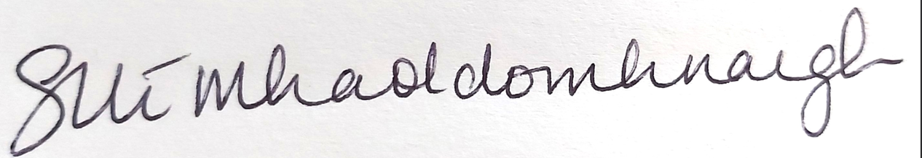
Cathaoirleach |  |  |  | Príomhoide
Dáta: 02/03/2026

