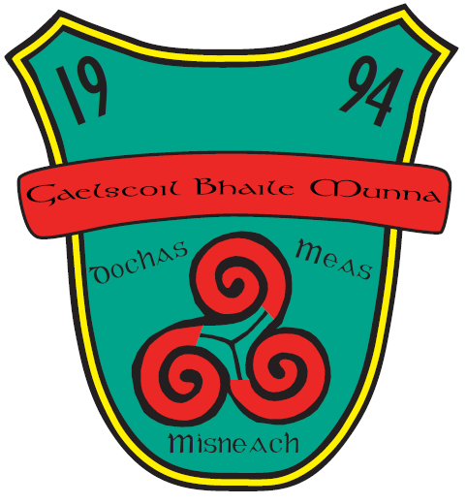
ANNUAL ADMISSION NOTICE
in respect of admissions to the 2026/2027 school year

Admission Policy and Application Form
A copy of the school’s Admission Policy and the Application Form for Admission for 2026/2027 is available as follows: –
To download at: www.gaelscoilbhailemunna.ie
On request: By emailing eolas@gaelscoilbhailemunna.ie or writing to: Gaelscoil Bhaile Munna, Bóthar Choltraí, Baile Munna, D09TY74 or in person from the school office.
PART 1 - Admissions to the 2026/2027 school year
Application and Decision Dates for admission to Gaelscoil Bhaile Munna 2026/2027
The following are the dates applicable for admission to Junior Infants:
The school will commence accepting applications for admission on | 01/10/2025
The school shall cease accepting applications for admission on | 22/10/2025
The date by which applicants will be notified of the decision on their application is | 12/11/2025
The period within which applicants must confirm acceptance of an offer of admission is | 26/11/2025

Note: the school will consider and issue decisions on late applications in accordance with the school’s admission policy.
*Failure to accept an offer within the prescribed period above may result in the offer being withdrawn.

Number of places being made available in Junior Infants 2026/2027
The number of places being made available in junior infants | 26
The number of places available in our special class | 2

